CAM 11 – TEST 1
SECTION 1
VOCABULARY
No. | Vocabulary | IPA | POS | Meaning | Synonym
1 | enquire | /ɪnˈkwaɪə(r)/ | v | hỏi, yêu cầu thông tin | ask, request information
2 | seating | /ˈsiːtɪŋ/ | n | chỗ ngồi | seats, sitting area
3 | raise money | /reɪz ˈmʌni/ | phr | gây quỹ | collect funds, fundraise
4 | charity | /ˈtʃærəti/ | n | tổ chức từ thiện | non-profit, aid organisation
5 | deposit | /dɪˈpɒzɪt/ | n | tiền đặt cọc | down payment, advance
6 | returnable | /rɪˈtɜːrnəbl/ | adj | có thể hoàn lại | refundable
7 | insist | /ɪnˈsɪst/ | v | khăng khăng, yêu cầu | demand, require
8 | actual | /ˈæktʃuəl/ | adj | thực tế | real, true
9 | charge | /tʃɑːdʒ/ | n/v | phí; tính phí | fee, cost
10 | licence | /ˈlaɪsns/ | n | giấy phép | permit, authorisation
11 | caretaker | /ˈkeəteɪkə(r)/ | n | người trông coi | janitor, supervisor
12 | van | /væn/ | n | xe tải nhỏ, xe chở hàng | delivery vehicle, truck
13 | fiddle | /ˈfɪdl/ | v | nghịch, chạm vào | touch, handle
14 | legal | /ˈliːɡl/ | adj | hợp pháp | lawful, permitted
15 | back door | /ˌbæk ˈdɔː(r)/ | n | cửa sau | rear entrance
16 | stage door | /ˌsteɪdʒ ˈdɔː(r)/ | n | cửa sân khấu | performer entrance
17 | speech | /spiːtʃ/ | n | bài phát biểu | talk, presentation
18 | microphone | /ˈmaɪkrəfəʊn/ | n | micro | mic, audio device
19 | detergent | /dɪˈtɜːdʒənt/ | n | chất tẩy rửa | cleaning agent, soap
20 | sweep | /swiːp/ | v | quét | clean, brush
21 | swept | /swept/ | v (past) | đã quét | cleaned, brushed
22 | decoration | /ˌdekəˈreɪʃn/ | n | đồ trang trí | ornament, adornment
23 | afterwards | /ˈɑːftəwədz/ | adv | sau đó | later, subsequently
24 | stack | /stæk/ | v | xếp chồng | pile up, arrange
25 | neatly | /ˈniːtli/ | adv | gọn gàng | tidily, orderly
SECTION 1
Questions 1 – 10
Complete the notes below.
Write ONE WORD AND/OR A NUMBER for each answer.
HIRING A PUBLIC ROOM
Example
● the Main Hall – seats ……….200……….
Room and cost
● the 1………….. Room – seats 100
● Cost of Main Hall for Saturday evening: 2 £……………
+ £250 deposit (3…………… payment is required)
● Cost includes use of tables and chairs and also 4……………..
● Additional charge for use of the kitchen: £25
Before the event
● Will need a 5……………. licence
● Need to contact caretaker (Mr Evans) in advance to arrange 6…………….
During the event
● The building is no smoking
● The band should use the 7…………….. door at the back
● Don’t touch the system that controls the volume
● For microphones, contact the caretaker
After the event
● Need to know the 8……………. for the cleaning cupboard
● The 9…………….. must be washed and rubbish placed in black bags
● All 10……………. Must be taken down
● Chairs and tables must be piled up

AUDIOSCRIPT (Section 1)
OFFICIAL: Hello?
WOMAN: Oh, hello. I wanted to enquire about hiring a room in the Village Hall, for the evening of September the first.
OFFICIAL: Let me just see … Yes, we have both rooms available that evening. There’s our Main Hall – that’s got seating for 200 (Example) people. Or there’s the Charlton Room …
WOMAN: Sorry?
OFFICIAL: The (1) ……………… Room – (1) …………………….. That’s got seating for up to one hundred.
WOMAN: Well, we’re organising a dinner to raise money for a charity, and we’re hoping for at least 150 people, so I think we’ll go for the Main Hall. How much would that cost?
OFFICIAL: Let’s see. You wanted it for the evening of September 1st?
WOMAN: Yes, that’s a Saturday.
OFFICIAL: So from six pm to midnight that’d be £ (2) ……… – that’s the weekend price, it’s £75 on weekdays.
WOMAN: That’s all right.
OFFICIAL: And I have to tell you there’s also a deposit of £ (3) …………, which is returnable of course as long as there’s no damage. But we do insist that this is paid in (4) ……….. , we don’t take cards for that. You can pay the (5) ……………………… of the room however you like though – cash, credit card, cheque …
WOMAN: Oh, well I suppose that’s OK. So does the charge include use of tables and chairs and so on?
OFFICIAL: Oh, yes.
WOMAN: And what about parking?
OFFICIAL: Yeah, that’s all (6) ……………….. The only thing that isn’t includes is … you said you were organising a dinner?
WOMAN: Yeah.
OFFICIAL: Well, you’ll have to pay (7) ………………. for the kitchen if you want to use that. It’s £ (8) ……….. It’s got very good facilities – good quality cookers and fridges and so on.
WOMAN: OK, well I suppose that’s all right. We can cover the cost in our (9) ………………..
OFFICIAL: Right. So I’ll make a note of that. Now there are just one or two things you need to think about before the event. For example, you’ll have to see about getting a (10) ………………….. if you’re planning to have any music during the meal.
WOMAN: Oh, really?
OFFICIAL: It’s quite straightforward, I’ll give you the details later on. And about a week or ten days before your event you’ll need to (11) ……………….. the caretaker, that’s Mr Evans, to make the arrangements for (12) ……………… – he’ll sort that out with you.
WOMAN: And do I give him the payment as well?
OFFICIAL: No, you do that directly with me.
——————
WOMAN: Right. Now is there anything I need to know about what happens during the event?
OFFICIAL: Well, as you’ll be aware, of course the building is no smoking (13) ………………….
WOMAN: Of course.
OFFICIAL: Now, are you having a band?
WOMAN: Yes.
OFFICIAL: Well, they’ll have a lot of equipment, so rather than using the front door they should park their van round the back and use the stage door there . You can open that from inside but don’t forget to lock it at the end.
WOMAN: OK.
OFFICIAL: And talking of bands, I’m sure I don’t need to tell you this, but you must make sure that no one (14) ………………. about with the black box by the fire door – that’s a system that cuts in when the volume reaches a certain level. It’s a (15) …………….. requirement.
WOMAN: Sure. Anyway, we want people to be able to talk to one another so we don’t want anything too loud. Oh, that reminds me, we’ll be having speeches – are there any microphones available?
OFFICIAL: Yeah. Just let the caretaker know, he’ll get those for you. Right, now when the event is over we do ask that the premises are left in good condition. So there’s a locked (16) …………………… and you’ll be informed of the (17) ……………… you need to open that. It’s got all the cleaning equipment, brushes and detergent and so on.
WOMAN: Right. So what do we need to do after everyone’s gone? (18) ………………. the floors I suppose?
OFFICIAL: Well, actually they have to be (19) ………………, not just swept. Then you’ll be provided with black (20) ………………. bags, so all the rubbish must be collected up and left outside the door.
WOMAN: Of course. We’ll make sure everything’s left tidy. Oh, and I forgot to ask, I presume we can have (21) ………………… in the room?
OFFICIAL: Yes, but you must take them down afterwards.
WOMAN: Sure.
OFFICIAL: And the chairs and tables should be stacked up neatly at the back of the room
WOMAN: I’ll make sure I’ve got a few people to help me.

SECTION 2
VOCABULARY
No. | Vocabulary | Phonetic | POS | Meaning | Synonym
1 | open-air | /ˌəʊpən ˈeə/ | adj | ngoài trời | outdoor
2 | rural | /ˈrʊərəl/ | adj | nông thôn | countryside
3 | agriculture | /ˈæɡrɪkʌltʃə/ | n | nông nghiệp | farming
4 | typical | /ˈtɪpɪkəl/ | adj | điển hình | standard
5 | staff | /stɑːf/ | n | nhân viên | employees
6 | safety tip | /ˈseɪfti tɪp/ | n | lời khuyên an toàn | safety advice
7 | advice | /ədˈvaɪs/ | n | lời khuyên | suggestion
8 | frighten | /ˈfraɪtən/ | v | làm sợ | scare
9 | injure | /ˈɪndʒə/ | v | làm bị thương | hurt
10 | breed | /briːd/ | n | giống (động vật) | type, variety
11 | rare | /reə/ | adj | hiếm | uncommon
12 | safe distance | /seɪf ˈdɪstəns/ | n | khoảng cách an toàn | proper distance
13 | tool | /tuːl/ | n | dụng cụ | instrument
14 | sharp point | /ʃɑːp pɔɪnt/ | n | đầu nhọn | sharp tip
15 | touch | /tʌtʃ/ | v | chạm | feel
16 | slip | /slɪp/ | v | trượt ngã | slide, fall
17 | sandals | /ˈsændəlz/ | n | dép | open shoes
18 | lamb | /læm/ | n | cừu con | young sheep
19 | in case | /ɪn keɪs/ | conj | phòng khi | if
20 | afraid | /əˈfreɪd/ | adj | e rằng, sợ | worried
21 | unless | /ənˈles/ | conj | trừ khi | except if
22 | guide dog | /ɡaɪd dɒɡ/ | n | chó dẫn đường | service dog
23 | layout | /ˈleɪaʊt/ | n | sơ đồ, bố cục | plan, map
24 | immediately | /ɪˈmiːdiətli/ | adv | ngay lập tức | at once
25 | main path | /meɪn pɑːθ/ | n | đường chính | main road
26 | farmland | /ˈfɑːmlænd/ | n | đất nông nghiệp | farming land
27 | scarecrow | /ˈskeəkrəʊ/ | n | bù nhìn | bird-scarer
28 | corner | /ˈkɔːnə/ | n | góc | angle
29 | beside | /bɪˈsaɪd/ | prep | bên cạnh | next to
30 | sculpture | /ˈskʌlptʃə/ | n | tượng điêu khắc | statue
31 | ahead | /əˈhed/ | adv | phía trước | in front
32 | maze | /meɪz/ | n | mê cung | labyrinth
33 | branch off | /brɑːntʃ ɒf/ | v phr | rẽ ra | split off
34 | hedge | /hedʒ/ | n | hàng rào cây | bush fence
35 | cross | /krɒs/ | v | băng qua | go over
36 | further up | /ˈfɜːðə ʌp/ | adv | xa hơn về phía trước | farther ahead
37 | towards | /təˈwɔːdz/ | prep | về phía | in the direction of
38 | along | /əˈlɒŋ/ | prep | dọc theo | following
39 | bend | /bend/ | n | khúc cua | curve
40 | craft | /krɑːft/ | n | nghề thủ công | handicraft
41 | woodwork | /ˈwʊdwɜːk/ | n | nghề mộc | carpentry
42 | basket-making | /ˈbɑːskɪt ˈmeɪkɪŋ/ | n | nghề đan giỏ | weaving
43 | by | /baɪ/ | prep | gần, cạnh | near
44 | field | /fiːld/ | n | cánh đồng | meadow
45 | picnic spot | /ˈpɪknɪk spɒt/ | n | chỗ dã ngoại | picnic area
46 | through | /θruː/ | prep | xuyên qua | across
47 | harm | /hɑːm/ | n/v | gây hại | damage, hurt
48 | take care | /teɪk keə/ | v phr | cẩn thận | be careful
49 | exception | /ɪkˈsepʃən/ | n | ngoại lệ | exclusion

SECTION 2
Questions 11 – 14
Complete the notes below.
Write ONE WORD for each answer.
Fiddy Working Heritage Farm
Advice about visiting the farm
Visitors should
● take care not to harm any 11……………..
● not touch any 12…………….
● wear 13…………….
● not bring 14……………. into the farm, with certain exceptions.

Questions 15-20
Label the map below.
Write the correct letter A-I, next to Questions 15-20.
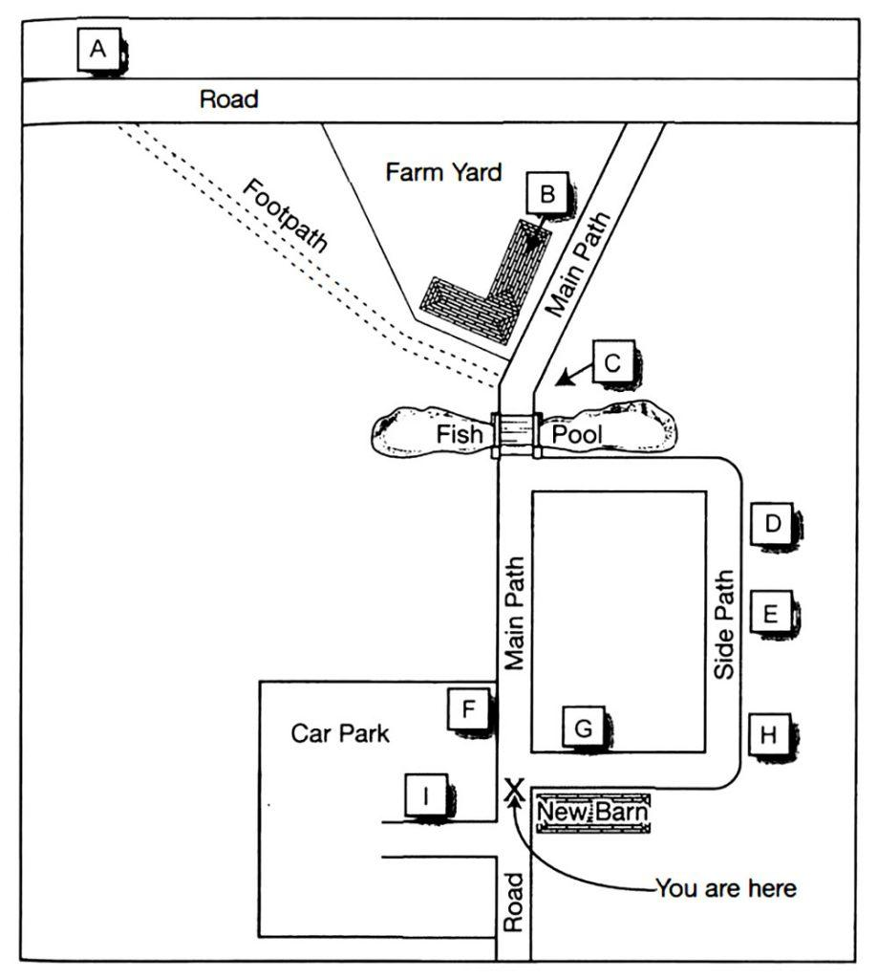
15 Scarecrow …………..
16 Maze …………..
17 Café …………..
18 Black Barn …………..
19 Covered picnic area …………..
20 Fiddy House …………..

